The 2022 NCCPPA convention was held in London Ontario on September 23rd & 24th. The executive and delegates visited Port Stanley where they boarded the Port Stanley Terminal Rail (PSTR), a heritage railway train, along with 38 London Chapter members and guests. They travelled on the train to the town of St. Thomas where they stopped were treated to dinner in the dining car on board the train.

……………..Tom Sonier, First Vice-President, NCCPPA

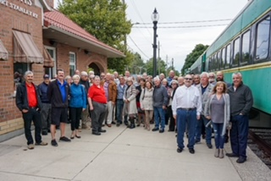Ready to board for a train ride and dinner – members of the London chapter and convention delegates.

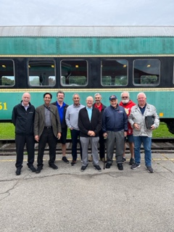

Delegates and Executive to the National Convention. From left, Rae Leduc, Delegate, Montreal; JarnailTaggar, Delegate, Calgary; Tom Sonier, 1st Vice President, Alternate Pension Representative London; Surinder Rehill, President, Calgary; Robert Cameron Delegate, Secretary and Pension Representative, Revelstoke; Arthur Wieckowski, Treasurer, Calgary; Peter Landry, Delegate, Pickering, Ontario; Bill Magone, Delegate, Windsor; Nick Dionne, Delegate , London; (Absent Gregory Neville, Delegate, Sudbury)

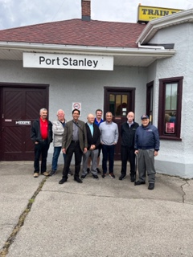

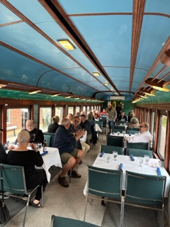 Ready to

At the station. Ready to dine

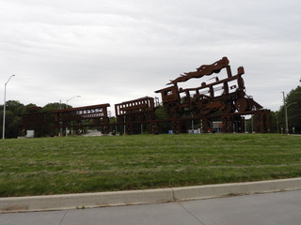

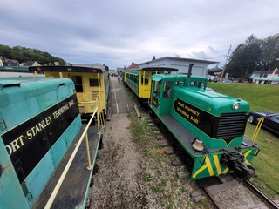

Port Stanley Terminal Rail (PSTR)