**NCCPPA EXECUTIVE: *As at January 1, 2023***

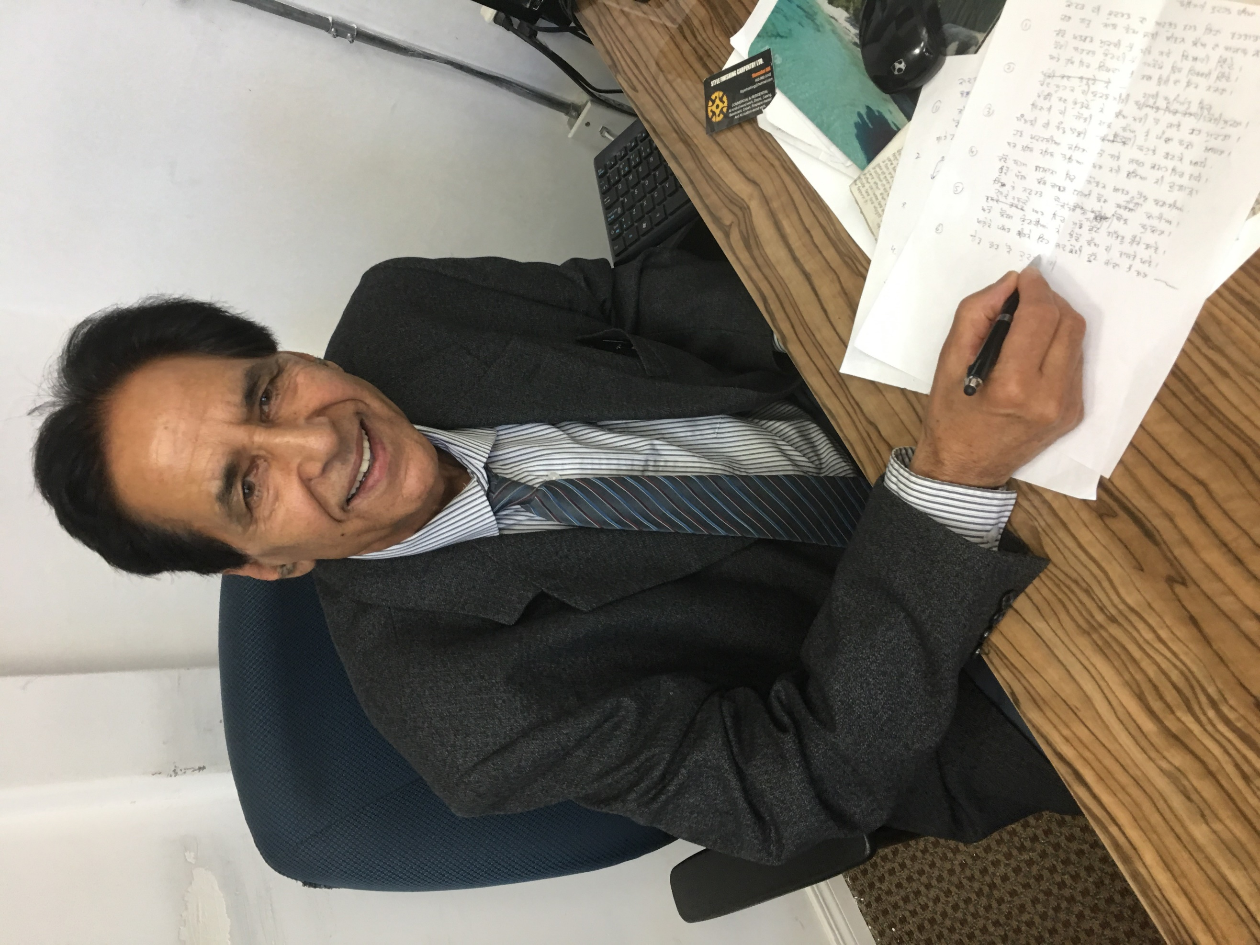

# **President – Jarnail S. (John) Taggar**

Email: hometaggar@hotmail.com

I worked as a Machinist at Ogden Shops from 1974 and retired in 2001. I was involved and active with the International Association of Machinists, and am a volunteer with the Monterey Punjabi Seniors Association here in Calgary. I am currently First Vice President of the Calgary chapter, and attended the September 2022 NCCPPA convention in London, Ontario as a delegate, and where I was elected President of the NCCPPA.

# **First Vice-President**

**And Alternate Pension Representative**.

I retired from Canadian Pacific in 2012. Elected at the 2015 NCCPPA Convention in May 2015, to the position of 3rd Vice- President and to the position of Alternate Pension Representative. Appointed to the position of 1st Vice - President in November 2018, and elected again in September 2022. Email: [soniert@rogers.com](mailto:soniert@rogers.com)

**Second Vice President -** Bill Magone, Windsor, ON.

**Third Vice President**

**Lou Guay**

Email: louguay67@yahoo,com

I hired on in 1980 as a yard checker in Lethbridge, Alberta. Over the next 35 years I worked a number of clerical positions in Lethbridge and then in Winnipeg.

I retired in September 2015, and joined Manitoba Branch of the NCCPPA the same year. In 2018 I became Manitoba Branch Treasurer, and in 2020 I took over the Manitoba Branch newsletter.  
  
I was elected to the NCCPPA executive at the September 2022 convention.

www.cp-pensioners.com

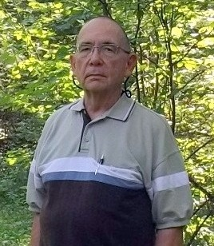

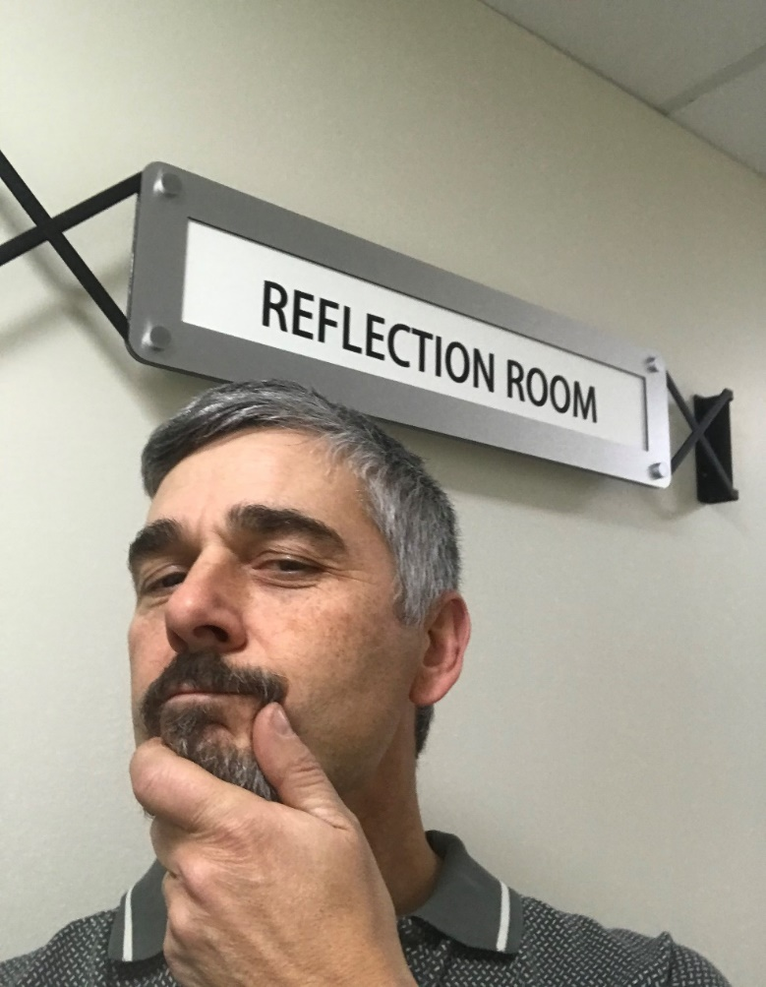

**Arthur Wieckowski – Treasurer, effective December 1st, 2021.**

After growing up near the railway tracks in East Vancouver I took an apprenticeship as a Boilermaker at Ogden Shops in Calgary and eventually entered management.  I worked throughout the Locomotive Department until the Shops closed in 2012 and moved to Head Office in Locomotive Maintenance Planning where I retired at the end of December 2017.  Soon after retirement I joined the Calgary Chapter and became Financial Director there a few months later.  Additionally, I became Treasurer for NCCPPA in December 2021, and was elected to this position in September 2022.  Email: arthurw@shaw.ca

Secretary and Pensioners’ Representative

I retired July 31, 2004 as a Locomotive Engineer at Revelstoke. I got involved with the Revelstoke Pensioners Association in 2005 and became the Secretary-Treasurer in 2008. I was elected to the position of Secretary of the National Council in May 2011 in London ON, was re-elected in May 2015 in Montreal, again in Kamloops, BC in May 2017, and again in September 2022 in London, ON. I took over from the late Henry Thiessen in September 2012 and I was elected Pension Representative in July 2014, re-elected in July 2017 and July 2020, and hold that job until August 31, 2023.

Email: [rjc48@telus.net](mailto:rjc48@telus.net)

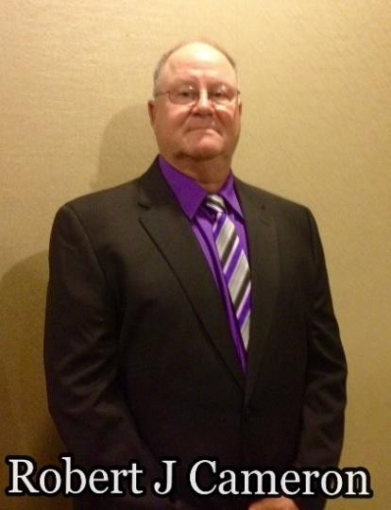

Immediate Past President - **Surinder Rehill**

2017 - 2022

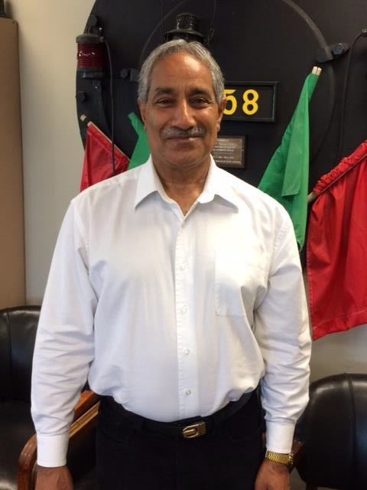

Email: [sngconsulting@hotmail.com](mailto:sngconsulting@hotmail.com)

After working in the Mechanical Department and Human Resources, I retired from CP Rail in July 2006. I joined the Calgary chapter in 2008 and as a delegate attended the 2013 NCCPPA convention in New Westminster.

From February 2014 to February 2019, I worked as President of Calgary chapter. Elected as President of National Council during May 2017 NCCPPA biennial convention held in Kamloops BC., until the September 2022 convention in London, Ontario.